It is type of deep learning neural network helps to generate new things like images, text.
HOW IT WORKS
It has two models generator(produces data), discriminator(classifies the produced data where there it is real or fake.
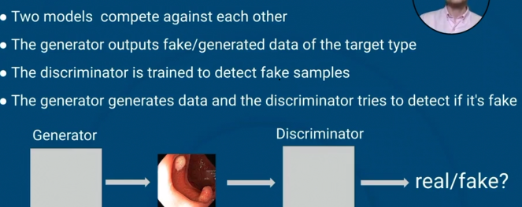

GENERATORE AND DISCRIMINATOR
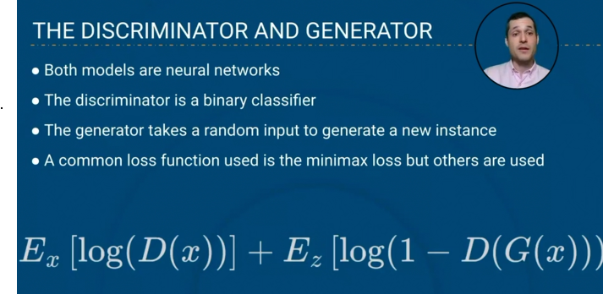
In the above image formula is the common loss function which is used on GAN.
In above image left hand side formula is for the expected values for all real data, right hand formula is for expected values for all fake data.
In right side formula G(x) is the output of generator. So it is called discriminator

HOW TO TRAIN GANs
Generator generates new sample -> discriminator tells how realistic the new sample is by comparing it by original sample, it return 0-fake and 1 for real -> Generator takes the feedback of discriminator and adjust the model’s weight to generate realistic image.
Once the generator is ready to fool the discriminator then our model it ready to generate images.
